ARMS4AI NOTES
TASK : GEOCODING IN GEOPANDAS
- Nominatim: geocoding service that uses openstreetmap data.
- Geocoders: GIS library like geopanda or geopy.
- Loop: Repeats the same task for multiple items
- latitude: North-South position
- Longitude: East-West position
CODE1 PRACTICE (GIVE SINGLE PLACE LOCATION):
In code1 the user agent means name of your application. And you give the location so openstreetmap data can be checked through nominatim. This data returns a location object containing coordinates and address information.
You put the code for latitude and longitude.you get the respective outputs. (give the print command for the output)
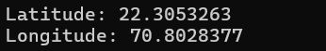
This is the sample output that shows coordinates of Rajkot city in Gujarat.
CODE2 MULTIPLE LOCATIONS:
Here I chose multiple cities for practice. Same start. Just here I form a loop so I don’t have to separately find the coordinates of each city. Loop does the same geocoding process without repeating the same command repeatedly. It gives the respective coordinates for all.
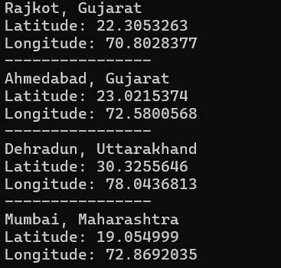
The output should look like this.

